WHAT-IF ANALYSIS AND SCENARIOS IN EXCEL
(without Data Tables)
The goal of What-If analysis, or Scenario analysis is to be able to project outcomes based on different scenarios of spreadsheet values. In order for “what-if” analysis or scenario analysis to work, formulas must be used that define relationships among spreadsheet values. For example, a simple scenario analysis might entail your desire to borrow $150,000 and repay the loan over five years. Different lenders offer different interest rates, ranging from 5% to 7%. You want to know what the monthly payments would be at each interest rate in this range. You might be tempted to use a manual approach, simply substituting each of the interest rates one at a time in the original data and recording the new monthly payment. However, a spreadsheet tool—scenario analysis can automate this process, as long as monthly payment is computed using a formula that includes the interest rate cell address as an operand. For example:
Steps:
1. Create a worksheet such as that shown below:
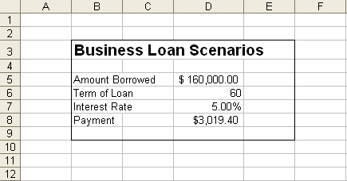
Note that the formula entered in cell D8 is our previously discussed PMT function: = PMT (rate, Nper,- PV). Thus, in cell D8, we have entered =PMT(D7/12,D6,-D5).
- Now, let’s look at scenarios that compute the monthly payment for different interest rate values. To create a scenario, click Tools Scenario on the Menu bar. This will open the Scenario Manager dialog box:
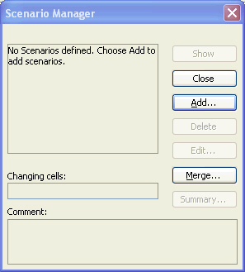
- This is where you set up your scenarios, one by one. We are interested in computing the monthly payments for different interest rate values. So, interest rate will be the item that changes its value in each scenario.
To Add a new Scenario:
  - Click the Add button in the Scenario Manager dialog box
  - Type a name for the scenario. As you see in the following, I entered Scenario1 as the name of my first scenario:
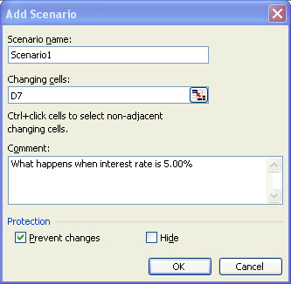
  - Next specify which cells will change values (Changing cells:) in the different scenarios. In our example, we are only changing the interest rate value. So D7 is specified as the block of changing cells.
  - The Comment area is used for tracking purposes to differentiate the scenarios and to document when each was created or why each was created.
  - Click OK.
  - The next dialog box prompts you for the first scenario value for the changing cell. It is generally recommended that you specify the initial value from the spreadsheet. So in this example, enter 5.00% and click OK.
  - Add additional scenarios by clicking the Add button. For our purposes, add two additional scenarios as follows:

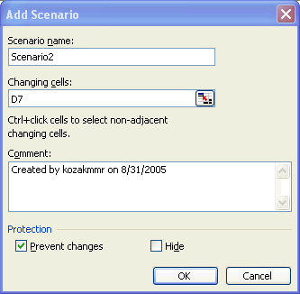 | 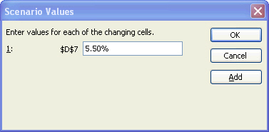
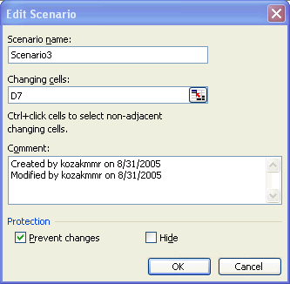 | 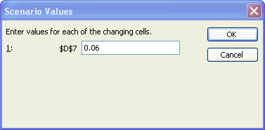

Three scenarios have now been created for this spreadsheet and the interest rate value in cell D7 specifically.

Note: The other buttons beside Add that appear on the Scenario Manager include:

Edit: This option enables you to change the highlighted scenario values
Delete: This option will delete the highlighted scenario from the spreadsheet

Show: This option will update the spreadsheet to reflect this scenario’s values. For example, highlight Scenario2 in the Scenario Manager dialog box below, and click Show to update the spreadsheet to reflect the monthly payment for a 5.50% interest rate:

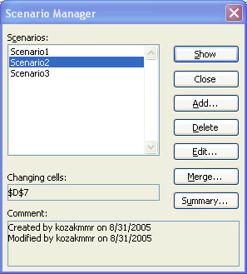

Note how the spreadsheet values change from this action.

The Summary option shown in the Scenario Manager dialog box above is very popular. It allows you to display a sheet that lists all of the scenario effects in summary form. For example, clicking the Summary option for our different loan scenarios and then selecting the Scenario Summary radio button produces a new Scenario Summary sheet that contains the following:

